I N D E X

Sl.No. | Content | Page No.
1 | Index | 1
2 | Important dates and Information | 2 – 3
3 | Introduction | 4 – 6
4 | About Institutions : | 7-8
4 | - Mizoram Polytechnic Lunglei | 7-8
4 | - Women’s Polytechnic Aizawl | 9 - 10
5 | Fee Structure for Polytechnics | 11 – 12
6 | Admission to the Institutions | 12-13
7 | Method of Selection and Categories, Examination fee | 13
8 | Application Form, Mode of Examination | 14 – 15
9 | Admit Card & Syllabus | 15-22
10 | Modalities for conduct of Entrance Examination, etc. | 23
11 | Instruction for filling up Application Form | 24-26
12 | Sample of Admit card | 27
13 | Instructions for use of OMR Answer Sheet | 28-29

IMPORTANT DATES (Tentative)

- Selling of Application Form(online) : 11th April – 19th May, 2025
- Last date of Submission of
Application form : 19th May, 2025 (Monday)
- Date of Examination : 27th May, 2025 (Tuesday)
- Engg./Tech/BCC : 10:00 am - 1:00 pm
- Modern Office Practice : 1:30 pm - 4:30 pm
- Issue of admit cards (Online) : 23rd May, 2025 (Friday)onwards
- Publication of Results : Second week of June, 2025 (Tentative)
- Date of Admission for Selected Candidates :

At Mizoram Polytechnic, Lunglei
Serial No. 1 - 110 : 19th June 2025 (Thursday)
Note: Seat allotment/ Admission will be made for serial No. 111 – 165 (Waiting List) in order of serial number from 10:00AM onwards subject to availability of vacant seats. Any candidate found absent when call for seat allotment/Admission shall be declared as decline and chances shall be made for the next candidate and so on.

At Women’s Polytechnic, Aizawl
All Candidates : 25st June, 2025 (Wednesday)
- Classes will commence from : 9th July, 2025 (Wednesday)

NOTE:-
* Candidates should bring all the Original Documents at the time of admission. No candidate shall be given admission without original documents.

* List of Documents to be attached:
  - Recent passport-size photograph (2MB)
  - Birth Certificate
  - HSLC Certificate
  - HSLC Marksheet
  - HSSLC Marksheet (for MOP candidates)
  - HSSLC Certificate (for MOP candidates)
  - Disability Certificate (if required)

* Documents to be produced at the time of counseling/admission:
  - Caste Certificate
  - Residential Certificate (Permanent)

- INTRODUCTION

Higher & Technical Education in Mizoram: Higher & Technical Education has been established as a separate Department out of trifurcation of Education Department in April, 1989. This Department looks after Higher Education from collegiate level and upwards including science & technical education in the State. The Technical Wing of Directorate of Higher & Technical Education functions as the Secretariat of the Mizoram State Council for Technical Education (MSCTE). There are two Polytechnics under MSCTE namely Mizoram Polytechnic, Lunglei (MPL), Women’s Polytechnics Aizawl (WPA). A common entrance test known as Mizoram Diploma Entrance Examination (MDEE) is used as the main criteria for selection of candidates for admission to the engineering / technology and other courses offered in these Institutions.

- JOB PROSPECTS & CAREER OPTIONS
    - Diploma in Civil Engineering
In the present job market scenario there are good placement opportunities available for the candidates having Diploma in Civil Engineering. Be it the government sector or the private companies, the fresh civil diploma holders are sure to get a job that suits their profile. The main job profiles for diploma holders in Civil engineering are site engineers engaged with the work of supervision, surveyors, quality control, estimation work, office procedures and draftsman. Many diploma engineers have started their own consultancy business in the field of construction and civil engineering.
    - Diploma in Electrical Engineering
It deals with the study of electricity, electronics, electromagnetism and their application. India is fast emerging as one of the largest economies of the world with a huge appetite for power and the scope in electrical engineering jobs in India are on the rise. In this area, the engineers' task involves generation, transmission and distribution of electricity and instrumentally processing the format in the fields of communication, control system, information technology, industrial electronics and instrumentation etc.

    - Diploma in Mechanical Engineering
Candidates having a Diploma in Mechanical Engineering can look for jobs in the fields of designing, mechanical drafting, costing and estimating, maintenance of machine and modification of the existing designs. Most of the engineering companies absorb suitable candidates as trainees in their organization. Some of the job profiles for fresh mechanical engineering diploma holders are detailing engineers, CAD Application Engineers, Engineer Trainee, Trainee Design Engineer, Design Engineer Mechanical, Draughtsman Auto Cad and Structural Engineer.
    - Diploma in Computer Science & Engineering
On completion of Diploma in Computer Science & Engineering, plenty of career opportunities exist in the IT industry. They can find openings as Software Engineers, System Developers and Programmers. As they get sufficient exposure to learn computer hardware, they can become Hardware Engineers too. They can also become Network Engineers. They are eligible for the Apprenticeship training program in Industries / Organizations. Infinite opportunities in the field of Web and Multimedia designing are available. Most Multi National Corporations (MNCs) prefer diploma students for Business Process Outsourcing (BPO) and Call Centre jobs.
    - Diploma in Modern Office Practice
Graduates of the diploma program may expect to find employment opportunities in both the public and private sectors, including all levels of government offices, accounting firms, hospital and educational organizations and general business offices. The Diploma holders having gained insight into the creation of a small business may start out on their own enterprise. The Diploma holders are trained for the following specific positions; administrative assistant, word processing operator, computerized book-keeping, data processing, microcomputer specialist as well as additional employment opportunities depending on the electives selected.

    - Diploma in Electronics & Telecommunication Engineering
On completion of diploma in Electronics & Telecommunication Engineering, engineers can get themselves a job in various private organization and government agencies. The engineers can vie for various posts in the Central Government, State Governments, Indian Telephone Industries, MTNL, Post and Telegraph Department,

Defense, All India Radio, Civil Aviation Department, Indian Railways Co-ordination Department, National Physical Laboratory, Bharat Electronics Limited, Development Centers, Entertainment industry, Research establishments and many other IT sectors. There are an overwhelming number of jobs in the telecommunication industry as well.

    - Diploma in Garment Technology
The Garment Industry is fast developing in India. Readymade garments are being manufactured in mass scale for sale in the domestic and foreign markets. Graduates of the diploma program in Garment Technology are expected to find employment opportunities both in the public and private sector in the field of manufacturing, apparel design, marketing and sourcing for major apparel companies and hi-fashion designers. Also there are plenty of opportunities of starting their own business.

    - Diploma in Beauty Culture & Cosmetology
The business of beauty is a multi-billion world-wide industry and even in the worst of times such as a recession, it is one of the few that still rakes in the profits. The students coming out of this course will find employment as beautician, spa therapist and hair dresser in private saloons and major hotels and resorts besides having the opportunity to start their own business. They can also become sales promoters for various national and international cosmetic products.

- ABOUT INSTITUTIONS

    - MIZORAM POLYTECHNIC, LUNGLEI:
The first Technical Institution in the State was established in 1981 under Higher & Technical Education Department, Mizoram. Most of the Laboratories and Workshops are newly constructed with the assistance of World Bank through Third Technician Education Project under Ministry of Human Resource Development (MHRD) Govt. of India. Recently, the Institute also received assistance under AICTE-NEQIP scheme for strengthening of existing laboratories, improvement of faculty and other academic reforms. Most of the laboratories have been equipped with latest technologies. The Institution is located at Hrângchalkâwn which is 8 kms from Lunglei town, 235 km from Aizawl via Hnahthial and about 170 km via Thenzawl. Polytechnic Bus and Town Bus services are the main mode of transportation from the heart of the Town of Lunglei and the adjoining villages.

    - COURSE OFFERED:
The Institute offers three years Diploma Courses in the following stream. All courses have been approved by All India Council for Technical Education (AICTE) and are equipped with latest state of the art technology.

    - NAME OF COURSES INTAKE CAPACITY
Civil Engineering - 30
Electrical Engineering - 30
Mechanical Engineering - 20
Computer Science & Engineering - 30
Total : 110

    - 10% of the intake capacity subject to the availability of seats which may be increased if more seats are vacant/available for passed outs of ITIs to join Polytechnics through Lateral Entry System.

    - LABORATORIES: State of the art Laboratory for every branch of Engineering.

    - HOSTELS: Well furnished Hostel for Boys and Girls accommodating around 100 boys and 45 girls.

    - LIBRARY: The Institution is equipped with latest edition of Books, Journals and Periodicals.

    - CO-CURRICULAR ACTIVITIES
    - There is National Service Scheme (NSS) Unit where each student is expected to enroll.

    - Institution Week is conducted annually where students participate in various games and sports and activities like quiz, debate and singing.

    - The institution has a Badminton court, Gymnasium and Basketball Court.

    - TRAINING & PLACEMENT
    - Final year students undertake Industrial Visit in and outside the state as part of the curriculum.
    - Apprenticeship training is provided to successful pass out students.
    - Assistance for job Training and Placement for job is provided to successful pass out students.

- WOMEN’S POLYTECHNIC, AIZAWL:
It was established in 1998 for upliftment and development of women in the field of Management, Engineering, Technology & Applied Arts and Crafts at Durtlâng, Aizawl and located at 8 km from the heart of the city. The buildings, Laboratory and Workshop are constructed under 3rd Technician Education Project of World Bank Assistance and equipped with latest state of the art facilities.
    - COURSE OFFERED: The Institute offers Diploma courses in the following stream. All the courses are approved by All India Council for Technical Education.

    - Name of Courses Intake Capacity
Modern Office Practice 30
Electronics & Telecommunication Engineering 30
Garment Technology 30
Beauty Culture and Cosmetology 30
Total 120

    - LABORATORY: State of the Art Laboratory for every branch of study.

    - HOSTEL: Well furnished Hostel for Girls accommodating around 100 Girls.

    - LIBRARY: The Institute is equipped with latest edition of Books, Journals and periodical.

    - CO-CURRICULAR ACTIVITIES
  - There is National Service Scheme (NSS) Unit where each student is expected to enroll.
  - Institute Week is conducted annually where students participate in various games and sports and activities like quiz, debate and singing.
  - The institute has Badminton, Volleyball court and a Gymnasium.
    - TRAINING & PLACEMENT
          - Final year students undertake Industrial Visit in and outside the state as part of curriculum.

          - Apprenticeship training is provided to successful pass out students.

c) Assistance for on the job. Training and Placement for job is provided to successful pas out students.

- COMMUNITY SERVICES:
In addition to the above academic courses, both polytechnic have been actively engaged in centrally sponsored community development through polytechnic schemes for the development and self-employment of rural community and other backward classes in the State. More skill development programs are now underway to be implemented in both polytechnics.

- FEE STRUCTURE FOR POLYTECHNICS :
In reference to the Govt. approval vide memo No.B.17011/1/2022-HTE Dt.08.06.2022 the following rates of fees for Polytechnics are to be effective from the Academic Session 2022-2023.

- INSTITUTION :
Sl.No. | Particulars | Approved Rates of Fees (in Rs.)
(1) | (2) | (3)
1. | Admission Fee | 120/-p.a.
2. | Tuition Fee | 200/-p.m
3. | Registration Fee | 60 /-one time
4. | Affiliation Fee | 20/- per student (one time)
5. | Library Fee | 300/- p.a
6. | Medical Fee | 100/- p.a
7. | Laboratory Fee | 400/- p.a
8. | Internal Examination Fee | 150/- p.a
9. | Institution Development Fee | 1000/- p.a
10. | Identity Card Fee | 150/- (one time)
11. | Transportation Charge | 100/- p.a
12. | Electric and Water Charges | 250/- p.a
13. | Students Union Fee | 200/- p.a
14. | Games and Sports Fee | 200/- p.a
15. | Magazine Fee | 200/ -p.a
16. | Caution Money | 250/- p.a
Grand Total |  | 3700/-

- HOSTEL :
In reference to the Govt. approval vide memo No.A.33023/1/2022-HTE/Pt-I Dt.06.06.2022 the following rates of Hostel fees for Polytechnics are to be effective from the Academic Session 2022-2023.
Sl.No. | Particulars | Approved Rates (in Rs.)
(1) | (2) | (3)
1. | Admission Fee | 500/-p.a
2. | Establishment Fee | 200/- p.a
3. | Medical Fee | 500/- p.a
4. | Game Fee | 500/- p.a
5. | Caution deposit | 500/- (refundable)
6. | Seat Rent | 300/- p.m
7. | Light & Water Charges | 200/- p.m
8. | Mess fee | 3000/- p. m.
Grand Total |  | 5700/-

3. EXAMINATION FEES

Sl.No. | Item | Rate (in) | Time/Mode of Payment
1 | Examination fee | 400/- | Per Semester/Term
2 | Examination fee for backlog/  Drop (Theory/Practical) | 150/- | Per paper
3 | Practical Exam fee | 300/- | Per Semester/Term
4 | Centre fee | 400/- | Per Semester/Term
5 | Admit Card fee | 50/- | Per Semester/Term
6 | Marksheet fee | 50/- | Per Semester/Term
7 | Certificate fee | 100/- | For pass out student
8 | Marksheet fee | 100/- | For pass out student
9 | Migration Certificate fee | 200/- | For pass out student
10 | Examination late fee | 500/- | For each per semester/term

Note :
  - These fees are to be collected from students at the time of filling up of Term-End Examination Application forms.
  - The Practical Examination Fee is to be utilized for conduct of Practical Examination in the Institution.
- ADMISSION TO DIPLOMA COURSES IN ENGINEERING / TECHNOLOGY
- Eligibility of Candidates:

- A citizen of India.
- Has passed High School Leaving Certificate (HSLC) Examination or its equivalent with Science and Mathematics conducted by any recognized Board of the State or Central Government for Engineering/ Technology.

- Has passed High School Leaving Certificate (HSLC) or its equivalent (preferably with Science) conducted by any recognized Board of the State or Central Government for Garment Technology and Beauty Culture & Cosmetology.
- Has passed Higher Secondary School Leaving certificate (HSSLC) Examination or its equivalent in any course conducted by any recognized Board of the State or Central Government for Modern Office Practice course.
- Has passed the High School Leaving Certificate Examination (HSLC) or its equivalent with Science and Mathematics conducted by any recognized Board of the State or Central Government or have appeared in the High School Leaving Certificate (HSLC) Examination but the result of such Examination having not been declared for other courses.
- Provided that such applicants who have not got their result sheets at the time of submission of their applications, should submit their final results with Mark Sheet within fifteen days from the date of publication of their results by the concerned Examination Board.
- Age limit will be between 15-25 years and there will be 5 years upper age limit relaxation for Scheduled Tribe/Scheduled Caste/ Other Backward Classes. Age limit for department candidates for direct admission on nomination from State Government Department / Autonomous District Council within Mizoram State will be up to 45 years.

- METHOD OF SELECTION AND CATEGORIES
Method of Categorization and method of Selection to be applied will be notified by competent authority in due course of time.

- EXAMINATION FEE
Information Brochure may be downloaded from website www.dhte.mizoram.gov.in
Every candidate shall have to pay 250/- (Rupees two hundred fifty) as Examination fees.

Fees once paid shall not be refunded.

- APPLICATION FORM[ Online]
            - All application forms must be properly filled in.
            - Incomplete application form shall be rejected.
            - Applications received after last date shall not be entertained.

- MODE OF EXAMINATION
Selection of Candidates shall be done through Mizoram Diploma Entrance Examination (MDEE) in Science, Mathematics, English and General Studies (for MOP) as prescribed from time to time by the concerned discipline. The Compulsory papers for each of the courses are given in Table

    - Compulsory papers for each Diploma course

    - The standard of Entrance Questions to be answered by the candidates of Serial No. 1 & 2 in Written Examination shall be equivalent to the courses of HSLC (Class X) standard of the Mizoram Board of School Examination (MBSE) and Candidates of Serial No. 3(except Mathematics) shall be of HSSLC (Class XII) standard of MBSE.
Sl.  No | Courses | Entry Level | Compulsory Papers
1. | Engineering & Garment Technology | HSLC or equivalent | Mathematics, Physics, Chemistry, English
2 | Beauty Culture & Cosmetology | HSLC or equivalent | Biology, Physics, Chemistry, English
3 | Modern Office Practice | HSSLC or equivalent | English, General Studies,  Mathematics
    - Marks Distribution for Engineering/Technology:
Mathematics - 30 Physics - 25
Chemistry - 25 English - 20
Total - 100

Marks Distribution for Beauty Culture & Cosmetology:
Biology - 30 Physics - 25
Chemistry - 25 English - 20
Total - 100

Marks Distribution for Modern Office Practice:
Mathematics - 40 English - 30
General Studies - 30
Total – 100

    - All the Entrance Examination questions shall be Multiple Choice Question (MCQ). Each candidate will be provided OMR answer sheet 15 minutes before commencement of the examination. Candidates will fill in the required particulars on the answer sheet with black/blue Ball Point Pen only. Candidates shall bring their own pens with them for use during examination.

    - Written Examination shall be conducted by the Technical Wing under Higher & Technical Education on behalf of the Mizoram State Council for Technical Education.

- ADMIT CARD
    - All candidates should bring their Admit Card for entry to the Examination Hall and produce the same before the Invigilator or any other Officers as may be authorized before and during the conduct of the Examination.

    - Candidates should retain their Admit Card to check exam results.

- SYLLABUS
All eligible candidates shall have to appear for a Written Test / Examination as per prescribed syllabus given below: (Syllabus for MOP Mathematics is HSLC standard)

      - SYLLABUS FOR ENGINEERING/TECHNOLOGY / BEAUTY CULTURE:

PHYSICS

          - Motion: Distance and displacement, volume; uniform and non-uniform motion along straight line; acceleration, distance-time and velocity-time graphs for uniform and uniformly accelerated motion.

          - Force and Newton’s laws : Force and motion, Newton’s laws of motion, inertia of a body, inertia and mass, momentum, force and acceleration, elementary idea of conservation of momentum, action and reaction forces.
          - Gravitation and Floatation : Gravitation; universal law of gravitation, force of gravitation of the earth (gravity), acceleration due to gravity; mass and weight; free fall, thrust and pressure, Archimedes’ principle, buoyancy, elementary idea of relative density.
          - Work and Energy : Work, Energy and Power Work done by a force, power; kinetic and potential energy; law of conservation of energy.
          - Sound : Nature of sound its propagation in various media, speed of sound, range of hearing in humans; ultrasound; reflection of sound; echo and SONAR, structure of the human ear (auditory aspect only).
          - Natural Phenomena: Convergence and divergence of light. Images formed by a concave mirror; related concepts; centre of curvature; principal axis. Optic centre, focus, focal length. Refraction; laws of refraction. Image formed by a convex lens; functioning of a lens in human eye; problems of vision and remedies.
          - Magnets and Effects of Current: Magnetic field, field
lines, field due to a current carrying wire, field due to current carrying coil or solenoid; Force on current carrying conductor, Fleming’s left hand rule. Electromagnetic induction. Induced potential difference, Induced current. Direct current. Alternating current; frequency of AC. Advantage of AC over DC. Domestic electric circuits. Potential, Potential difference, Ohm’s law; Series combination of resistors, parallel combination of resistors; Power: dissipation due to current; Interrelation between P,V,I and R.

_________________

CHEMISTRY

- Matter in Our Surroundings: Definition of matter; Particle nature, solid, liquid and gas; characteristics shape, volume, density; change of state-melting (absorption of heat), freezing, evaporation (Cooling by evaporation), condensation, sublimation.
- Is Matter Around Us Pure: Elements, compounds and mixtures. Heterogonous and homogenous mixtures, colloids and suspensions.
- Atoms and Molecules: Atoms and molecules. Law of constant proportions. Atomic and molecular masses. Mole Concept, Relationship of mole to mass of the particles and number, Valency, Chemical formula of common compounds.
- Structure of the Atom: Electrons, protons and neutrons; Isotopes and isobars. Cell-Basic Unit of life : Cell as a basic unit of life; prokaryotic and eukaryotic cells, multi-cellular organisms; cell membrane and cell wall, cell organelles; chloroplast, mitochondria, vacuoles, ER, Golgi apparatus; nucleus, chromosomes-basic structure and number.
- Chemical Substance-Nature and Behaviour
Acids, bases and salts: General properties, examples and uses.
- Chemical reactions: Types of chemical reactions: combination, decomposition, displacement, double displacement, precipitation, neutralization, oxidation and reduction in terms of gain and loss of oxygen and hydrogen.
- Metals and non-metals: Brief discussion of basic metallurgical processes. Properties of common metals. Elementary idea about bonding.
- Carbon Compounds: Carbon compounds, elementary idea about bonding. Saturated hydrocarbons, alcohols, carboxylic (no preparation, only properties). Some Important chemical compound: Soap-cleansing action of soap. Periodic classification of elements
_________________

MATHEMATICS

- Number System: Irrational number as non-terminating and non-repeating decimals. Real numbers and the real number line. Surds and Rationalization of surds. Representation of sets, equal sets, subjects, power set, universal set.
- Commercial Mathematics: Simple and Compound Interest, Ratio and Proportion, Cost of Living Index, Sales tax, Installments payments and installments buying.
- Algebra: Polynomials - G.C.D and L.C.M of polynomials by factorization, Linear Equations in Two Variables, Quadratic Equations, Arithmetic Progression
- Geometry: Lines and Angles, Concurrent Lines in a Triangle, Quadrilaterals and Parallelograms, Area and Circles.
- Coordinate Geometry: The Cartesian plane, co-ordinates of a point, linear equations of the type ax+by+c=0, Distance between two pairs and section formula (internal). Area of a triangle
- Trigonometry: Trigonometric ratios and identities, Trigonometric ratios of complementary angles, Simple problems on heights and distances.
- Mensuration: Concept of surface area, Surface areas and volumes of cubes, cuboids, spheres (including hemispheres) and right circular cylinders/cones.
- Statistics and Probability: Collection of data, presentation of data – tabular form, ungrouped/grouped, bar graphs, histograms (with varying base lengths), frequency polygons. Mean, median, mode of ungrouped data. Pictorial representation of data
- Time, Distance and Work: Solution of problems based on time, work and distance.
_________________

ENGLISH

- Verbs and Tenses: Present/past forms Simple/continuous forms Perfect forms, Future time reference
- Sentence Structure : Connectors, Types of sentences Affirmative, interrogative sentences, Negation Exclamations
- Other Areas, determiners, pronouns, prepositions Punctuation, synonyms/antonyms, word order in sentence type
- Literature
- Character: as revealed through appearance and distinguishing features, socio - economic background, action/events, expression of feelings, speech and dialogues

- Plot/Story/Theme: emerging through main events, progression of events and links between them, sequence of events denoting theme

- Setting: as seen through time and place, socio-economic and cultural background, people, beliefs and attitudes

- Form: rhyme, rhythm, simile, metaphor, alliteration, pun, repetition
_________________

BIOLOGY

  - Tissues: Structure and functions of animal and plant tissues (four types in animals; meri-stematic and permanent tissues in plants).
  - Diversity in Living Organisms: Diversity of plants and animals-basic tissues in scientific naming, basis of classification. Hierarchy of categories/groups, Major groups of plants (salient features) (Bacteria, Thalophyta, Bryophyta, Pteridophyta, gymnosperms and Angiosperms). Major groups of animals (salient features) (Non-chordates up to phyla and chordates up to classes).
  - Why Do We Fall Ill: Health and its failure. Infectious and Non-infectious diseases, their causes and manifestation. Diseases caused by microbes (Virus, Bacteria and protozoans) and their prevention, Principles of treatment and prevention. Pulse polio programme.
  - Improvement in Food Resources: Plant and animal breeding and selection for quality improvement and management; use of fertilizers, manures; protection from pests and diseases; organic farming.
  - The world of the living:
  - Our environment: Environmental problems, their solutions. Biodegradable, non-biodegradable, Ozone depletion Life Processes: “living” things; Basic concept of nutrition, respiration, transport and excretion in plants and animals.
  - Control and Co-ordination in plants and animals: Tropic movements in plants; Introduction to plant hormones; control and co-ordination in animals: involuntary and reflex action, nervous system; chemical co-ordination, animal hormones.
  - Reproduction: Reproduction in plants and animals. Need for and methods of family planning. Safe sex vs HIV, AIDS. Child bearing and women’s health.
  - Heredity and evolution: Heredity; Origin of life: brief introduction; Basic concepts of evolution.

  - Natural Resources
Air, Water, Soil. Air for respiration, for combustion, for moderating temperatures, movements of air and it’s in bringing rains across India. Air, water and soil pollution ( brief introduction) Holes in zone layer and the probable damages. Bio-geo chemical cycles in natures; Water, oxygen, carbon, nitrogen. Different forms of energy, leading to different sources for human use: fossil fuels, solar energy; biogas; wind, water and tidal energy; nuclear energy. Renewable versus non-renewable resources.
_________________

      - SYLLABUS FOR MODERN OFFICE PRACTICE

ENGLISH

- Read and comprehend extended texts (prescribed and non-prescribed) in the following genres: fiction, science fiction, drama, poetry, biography, autobiography, travel and sports literature, etc.

- Text-based writing (i.e., writing in response to questions or tasks based on prescribed on unseen texts)

- Write formal/informal letters and applications for different purposes.
- Write items related to the workplace (minutes, memoranda, notices, summaries, reports; filling up of forms, preparing CVs, e-mail messages, etc.).

- The uses of different tense forms for different kinds of narration (e.g. media commentaries reports, programmes, etc.).

- The use of passive forms in scientific and innovative writings

- Converting one kind of sentence/clause into a different kind of structure as well as other items to exemplify stylistic variations in different discourses.

- Modal auxiliaries-uses based on semantic considerations.
_________________

GENERAL STUDIES

- Indian culture - Indian culture will cover the salient aspects of Art Forms, Literature and Architecture from ancient to modern times, Mizo heritage and culture
- Modern Indian history from about the middle of the eighteenth century until the present significant events, personalities, issues. The Freedom Struggle its various stages and important contributors /contributions from different parts of the country.
- Appointment to various Constitutional posts, powers, functions and responsibilities of various Constitutional Bodies. Governance and politics in Mizoram since 1947
- Indian Economy and issues relating to planning, mobilization of resources, growth, development and employment. Mizoram Economic Survey 2014-2015
- Science and Technology developments and their applications and effects in everyday life Achievements of Indians in science & technology; indigenization of technology and developing new technology.
- Awareness in the fields of IT, Space, Computers, robotics, nanotechnology, biotechnology and issues relating to intellectual property rights.
- Conservation, environmental pollution and degradation, environmental impact assessment Disaster and disaster management.
- Salient features of world’s physical geography.
- Ethics, human values – lessons from the lives and teachings of great leaders, reformers and administrators; role of family, society and educational institutions in inculcating values.
- World of Games and Sports – National and international
_________________

- MODALITIES FOR CONDUCT OF ENTRANCE EXAMINATION
    - Date of Examination: The Selection Test/Examination will be conducted every year as notified by the Secretary, Mizoram State Council for Technical Education.
    - Scheme of Examination
    - Duration of written examination is 3 hours.
    - The questions will be of objective type only.
    - Each objective question shall carry one or two mark(s). More than one answer indicated against a question will be deemed as incorrect answer. Questions without any response shall be awarded ZERO marks.
- EXAMINATION CENTRE
The Selection Examination shall be held every year at the place(s) notified by Secretary, Mizoram State Council for Technical Education.

- RULES TO BE FOLLOWED IN THE EXAMINATION HALL
All candidates have to follow rules indicated in Admit Card.

- RESULTS
The Technical Wing shall prepare a list of successful candidates in order of merit on the basis of the marks obtained in the Entrance Examination. The merit list shall be equal to the number of seats available for allotment in the reserved quota/seats in the concerned discipline. There shall also be waiting list equal to 50% of the merit list in each concerned discipline.

- INSTRUCTION FOR FILLING UP APPLICATION FORM
    - Name of Courses and Code
Sl.No. | Name of courses | Code
1 | Diploma in Civil Engineering | DCE
2 | Diploma in Electrical Engineering | DEE
3 | Diploma in Mechanical Engineering | DME
4 | Diploma in Computer Science & Engineering | DCSE
5 | Diploma in Electronics & Telecommunication Engineering | DETE
6 | Modern Office Practice | MOP
7 | Diploma in Garment Technology | DGT
8 | Diploma in Beauty Culture & Cosmetology | DBCC

    - Name of Exam Centres and Code
Mizoram Polytechnic, Lunglei - MPL
Women’s Polytechnic, Aizawl - WPA
    - Category and Code
Scheduled Tribe - ST
Scheduled Caste - SC
General - Gen
Other Backward Class - OBC
    - Religions and Code
Christianity - C
Hindu - H
Muslim - M
Sikh - S
Others - O
    - Gender and code
Male - M
Female - F
    - Nationality and Code
Indian - I
Others - F
    - Name of Board/University and Code
Mizoram Board of School Education - MBSE
Mizoram University - MZU
Other Boards - OB

- SAMPLE FOR FILLING OF APPLICATION FORM
Personal Information
Name : V.L. MAWIA RALTE
Father’s name : THANGLIANA
(in block letters)
Date of Birth : 03.07.1997
Place of Birth : Aizawl
Religion : Christian (if Christian)
Gender/Sex : M /F
Nationality : [I] (if Indian)
Caste : [ST] (if Scheduled Tribe)
Person with Disability : [Yes/ No]

Permanent Address:
Village/Veng : Dawrpui
Town/City/Khua : Aizawl
District : Aizawl District
State : Mizoram 796007

Contact No. : Landline : 0389-2340603
Mobile No. : 9632154870
Nearest Police Station : Aizawl Police Station

Particulars in Entry Qualification:
Last School attended : Modern English School
Name of Exam : HSLC/HSSLC
Name of Board : MBSE
Year of Passing : 2024
Full Mark : 1000
Total Mark obtained : 540
Division : I (if First Division)

Examination Centre:
Women’s Polytechnic : [WPA]
(If you choose Women’s Polytechnic, Aizawl)
Mizoram Polytechnic, Lunglei : [MPL]
(If you choose Mizoram Polytechnic, Lunglei)

List of Required Documents to be uploaded:
- Recent passport size photo *
- Birth Certificate *
- HSLC Certificate *
- HSLC Mark sheet *
- HSSLC Certificate (for MOP candidates)*
- HSSLC Mark sheet (for MOP candidates)*
- Disability Certificate (for disable applicants)

Note: The above mentioned documents marked with asterisk (*) are all mandatory for candidates who have already passed the required Entry qualification, whereas HSLC/HSSLC Mark sheet and Certificate are not mandatory for candidates who are awaiting results of the Entry Qualification.

Mr/Mrs. V.L. Mawia Ralte
Son/Daughter of Vanlalthanga
Bearing Roll No ______ (to be filled by Centre Supt)
is allowed to sit in the Mizoram Diploma Entrance
Examination : 2025

Written Examination: 27th May, 2025(Tuesday) at
Engg/Tech/BCC : 10:00 am - 1:00 pm
Modern Office Practice: 1:30 pm - 4:30 pm

Examination Centre for MDEE 2025
Mizoram Polytechnic, Lunglei
Women’s Polytechnic, Aizawl

Passport
- SAMPLE ADMIT CARD

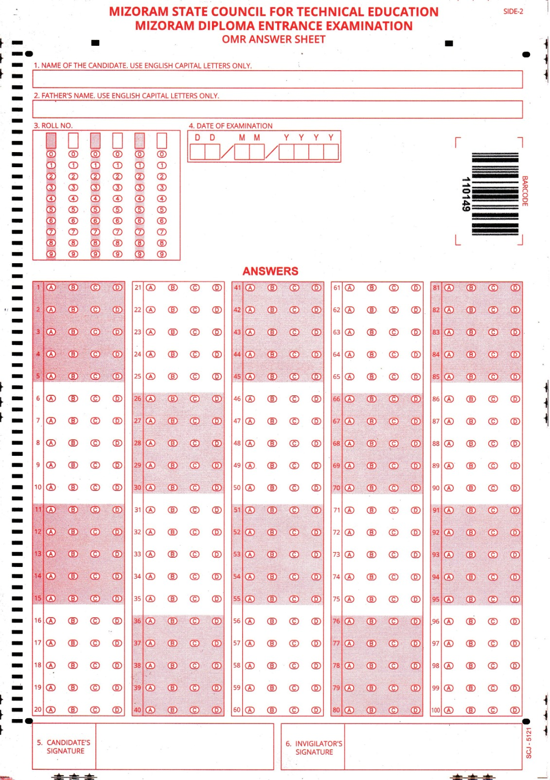
U. INSTRUCTIONS FOR USE OF OMR ANSWER SHEET
Fig: Sample OMR Sheet

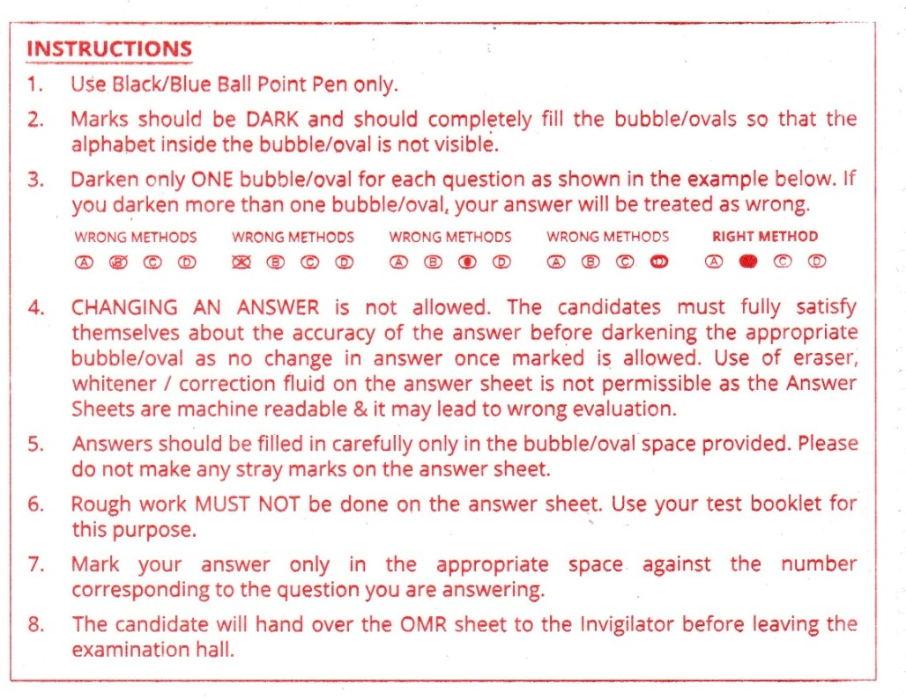
****************** End of Brochure ******************

